**ACKNOWLEDGEMENT**

We would like to express our sincere gratitude to all the individuals who have contributed to the successful development of SOFTWARE DEVELOPMENT PROJECT-I. This project has been an important part of our educational journey of our college and it couldn’t be possible without the support and guidance of all individuals and group of people.

First and foremost, we as a group would like to thank our Institute **ST. XAVIER’S COLLEGE(AUTONOMOUS) (DEPARTMENT OF COMPUTER SCIENCE),** for giving us the opportunity and considering us for SOFTWARE DEVELOPMENT PROJECT.

We express our gratitude to **Dr. (Fr.) JOHNSON MUNDUPUZHAKAL, the Vice Principal (SF COURSES)** **DEPARTMENT OF COMPUTER SCIENCES, ST. XAVIER’S COLLEGE(AUTONOMOUS)**, For arranging this wonderful opportunity and project training.

Secondly, we would like to thank our Software Development Project Coordinators **MR. DHWANIR SHAH** and **DR. MANALI BRAHMBHATT** for their guidance. Also, we are extremely grateful to **MS. KHUSHBOO SHAH** our Internal Guide, for her invaluable support. She not only taught us, but also guided, encouraged and motivated us all long into the completion of our project. Her knowledge and competence helped us a lot in designing various complex diagrams.

Additionally, we would like to thank **MR. PALLAV MAMTORA (CEO, TECHMICRA IT SOLUTIONS),** Our External Guide, who made sure that right resources were available to us at the right time. His experience, insights and feedback led to the completion of this project.

Lastly, we would also like to heartily thank all faculty member of **DEPARTMENT OF COMPUTER SCIENCES, ST. XAVIER’S COLLEGE(AUTONOMOUS)** for their timely advice.

21-BCA-025 KRISHNA HANDA

21-BCA-056 NAYAN PATIDAR

21-BCA-070 NIHAR SHAH

**INDEX**

**S.NO. TOPIC PAGE NO.**

1. INTRODUCTION……………………………………………………………………1
2. COMPANY PROFILE………………………………………………….………….…2
3. PROJECT PROFILE………………………………………………………………….3
   1. EXISTING SYSTEM……………………………….…………………….5
   2. PROPOSED SYSTEM…………………………………………………....6
   3. DEVELOPMENT TOOLS AND TECHNOLOGIES USED…….……….7
4. DATA FLOW DIAGRAM…………………………………………………………….8
   1. LEVEL 0…………………………………………………………….…….9
   2. LEVEL 1………………………………………………………………….10
   3. LEVEL 2………………………………………………………………….11
   4. LEVEL 3………………………………………………………………….18

1. ENTITY RELATIONSHIP DIAGRAM...………………………………………...….20
2. DATA DICTIONARY…………………………………………………………...……22
3. BIBLIOGRAPHY…………………………………………………………………….28

**INTRODUCTION**

Our Documentation for the project “**TONSORIUM TWITS”** involves certain details and information about the organization “TECHMICRA IT SOLUTIONS” that provided us with the project definition. This is followed by a short briefing of requirements and analysis of our project, the existing system and our proposed system.

In our documentation process during the analysis stage, we've created a series of Data Flow Diagrams (DFD) that play a pivotal role in understanding and designing our system. It all begins with the context level diagram, providing a high-level overview of the system's interactions with key entities like ADMIN, VISITOR, TONSORIUM OWNER, TONSORIUM STAFF, and CUSTOMER. Moving on to the first-level DFD, we delve into the core relationships between entities, processes, and data tables, establishing a fundamental framework for the system's functionality.

For a more comprehensive understanding, we employ second-level DFDs, which elaborate on the workings of each process identified in the first level. Finally, the third level DFD offers detailed insights into specific processes, ensuring a thorough grasp of their operations. These DFDs collectively serve as a valuable guide throughout our development process, guaranteeing that the system aligns with its intended requirements and functions seamlessly.

The documentation includes a Data Dictionary, a crucial tool for database development and coding. This resource provides a comprehensive reference for the database's structure, encompassing details such as tables, fields, data types, relationships, and constraints. It plays a pivotal role in the development process, ensuring accuracy and consistency in database design and coding.Lastly, we have Entity Relationship Diagram to show the Relationships between tables.

Towards the end of documentation are mentioned the book/websites we referred to during the completion of our project work so far.

**COMPANY PROFILE**



**Techmicra IT Solutions** based in Ahmedabad have been providing IT solutions & services to organizations since 2013.

**Address –** Office No 12. First Floor Sanidhya Building, Ashram Rd, opp. UCO Bank,

Ellisbridge,

Ahmedabad, Gujarat 380006

The company started with web development and design solutions during its inception phase and now has more than 25 departments like CRM development, Branding solutions, ERP implementation solutions, database administration & development, business intelligence and data analytics and more. With over 40 plus employees we are continually growing in each and every technology/domain. Extensive training and research programs for all our trainers and developers strengthen our grip and make us better in what we do.

**Contact Person: Pallav Mamtora**  
**Contact No. 9727835207**

**PROJECT PROFILE**

**Tonsorium Twits** will be a web-based application which is used for the unisex Tonsorium. This system will manage the day-to-day tasks of the Tonsorium as well as maintains the customer, staff, offers, appointments of multiple tonsoriums located at various locations. Our web-application provides customers a platform where they can choose among multiple tonsoriums according to their preference, rating, review, etc.

**There are 5 entities in our System:**

* ADMIN
* VISITOR
* TONSORIUM OWNER
* TONSORIUM STAFF
* CUSTOMER

**ADMIN**

* Admin can Login using login credentials
* Admin can Manage Tonsorium Owners (Approve Tonsorium and De-Activate Tonsorium)
* Admin can Manage Customers (Approve and De-Activate)
* Admin can Manage Services (Add, Update and De-list Services)
* Admin can Manage Payments (Make Payment to Tonsorium Owners, receive payment from Customers, Manage Refund, etc.)
* Admin can View Feedback from Customers

**VISITOR**

* Visitor can View Tonsoriums
* Visitor can View Services of various Tonsoriums
* Visitor can Sign up as Tonsorium Owner or Customer by providing relevant details
* Visitor can View feedbacks of Tonsoriums and their Staff

**TONSORIUM OWNER**

* Tonsorium Owner can login using login credentials
* Tonsorium Owner can manage their own Tonsorium’s Services (Add, Update, De-Activate Services)
* Tonsorium Owner can manage Appointments (Cancel Appointments)
* Tonsorium Owner can manage Staff (Add staff, Update staff details, Remove staff, etc.)
* Tonsorium Owner can manage Payments (View)
* Tonsorium Owner can view feedback provided by Customers

**TONSORIUM STAFF**

* Tonsorium Staff can Login using login credentials
* Tonsorium Staff can manage Appointments (Accept/Decline and Cancel)
* Tonsorium Staff can view feedback provided by customers
* Tonsorium Staff can view work details (Total Customers served, ratings, etc.)

**CUSTOMER**

* Customer can login using login credentials
* Customer can view Tonsorium and their Services
* Customer can manage Appointments (Book, Cancel and Reschedule)
* Customer can make payments and request refund
* Customer can view and provide rating and feedback to Tonsorium and Tonsorium Sta

**EXISTING SYSTEM**

Currently there are many web-applications available online that provide system to manage only single tonsorium. These applications can only be used to handle day to day tasks of a single tonsorium (like appointment booking, payment management, staff management, inventory management and accounting etc. )

Some examples of such websites are:

[**https://www.miosalon.com/**](https://www.miosalon.com/)

[**https://respark.in/**](https://respark.in/)

[**https://www.tonsorium.co.uk/**](https://www.tonsorium.co.uk/)

Here, <https://www.miosalon.com/> and <https://respark.in/> are websites which provide tonsorium management services and <https://www.tonsorium.co.uk/> is a website of a tonsorium based in UK.

**PROPOSED SYSTEM**

* All existing systems provide services for only single Tonsorium.
* Our system provides platform to list down their Tonsorium online on our platform and customer can choose among multiple Tonsoriums available near their locations.
* They can Book, Schedule and Reschedule their appointment online from the convenience of their homes to save their precious time.
* Also, customer has option to choose Tonsoriums according to Ratings and Reviews in order to ensure that they get best services possible.

Therefore, our proposed system revolutionizes the grooming industry. It provides a user-friendly platform where customers can easily discover and book Tonsoriums (salons) that best suit their needs. No longer bound by geographic limitations, customers can explore nearby Tonsoriums and make informed choices based on Ratings and Reviews.

The system streamlines the appointment process, allowing customers to book, schedule, and reschedule appointments from the convenience of their homes, eliminating the need to wait in long queues. This innovation enhances customer experiences while motivating Tonsoriums to offer top-quality services. In just a few clicks, customers can save time, make smart choices, and enjoy a more efficient and enjoyable grooming experience.

**DEVELOPMENT TOOLS AND TECHNOLOGIES USED**

FRONT-END:



HTML 5  
CSS 3  
JavaScript 13   
REACT JS v18



BACK-END:

mongoDB v6.0.7  
Node JS v20



OTHER TOOLS:

MS PowerPoint 2021  
Draw.io v21.6.1  
Canva v1.38.0

**DATA FLOW DIAGRAM**

A data flow diagram can dive into progressively more detail by using levels and layers,

zeroing in on a particular piece. DFD levels are numbered 0, 1 or 2, and occasionally go

to even Level 3 or beyond. The necessary level of detail depends on the scope of what

you are trying to accomplish.

* DFD Level 0 is a basic overview of the whole system or process being analysed or modelled. It’s designed to be an at-a-glance view, showing the system as a single high-level process, with its relationship to external entities. It should be easily understood by a wide audience, including stakeholders, business analysts, data analysts and developers.
* DFD Level 1 provides a more detailed breakout of pieces of the Context Level Diagram. You will highlight the main functions carried out by the system; as you break down the high-level process of the Context Diagram into its subprocesses.
* DED Level 2 then goes one step deeper into parts of Level 1. It may require more text to reach the necessary level of detail about the system’s functioning.

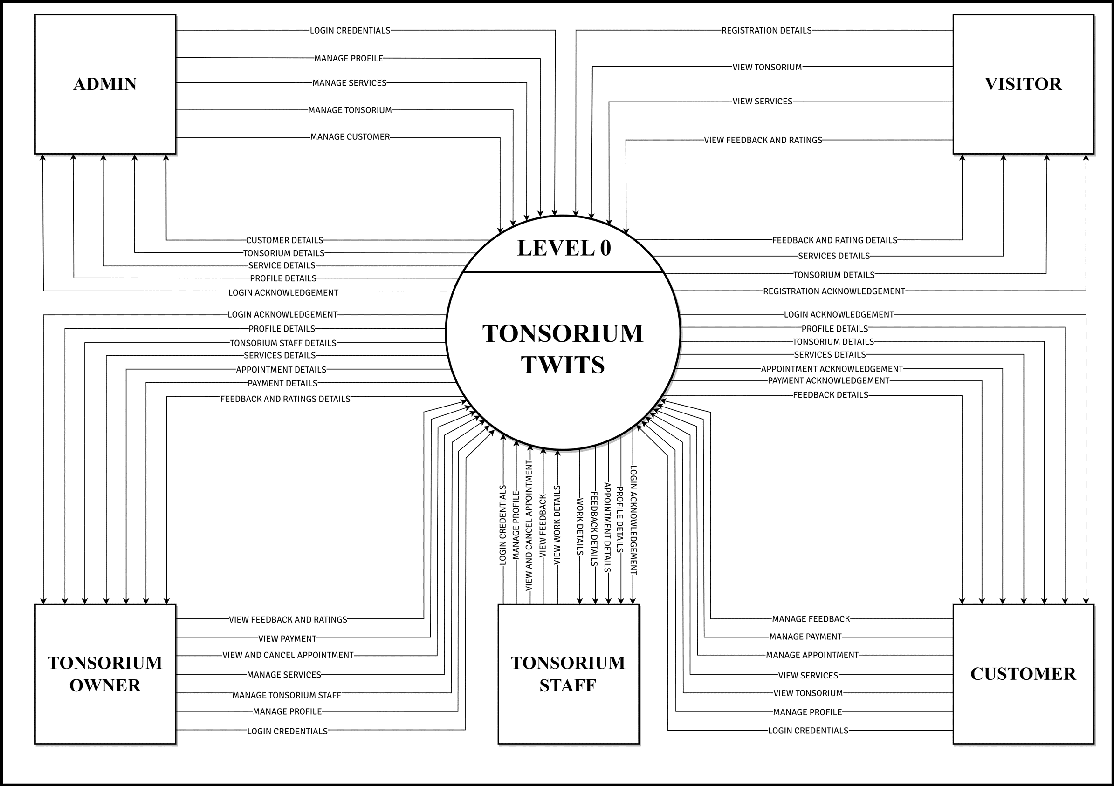**DFD LEVEL 0**

**DFD LEVEL 1**

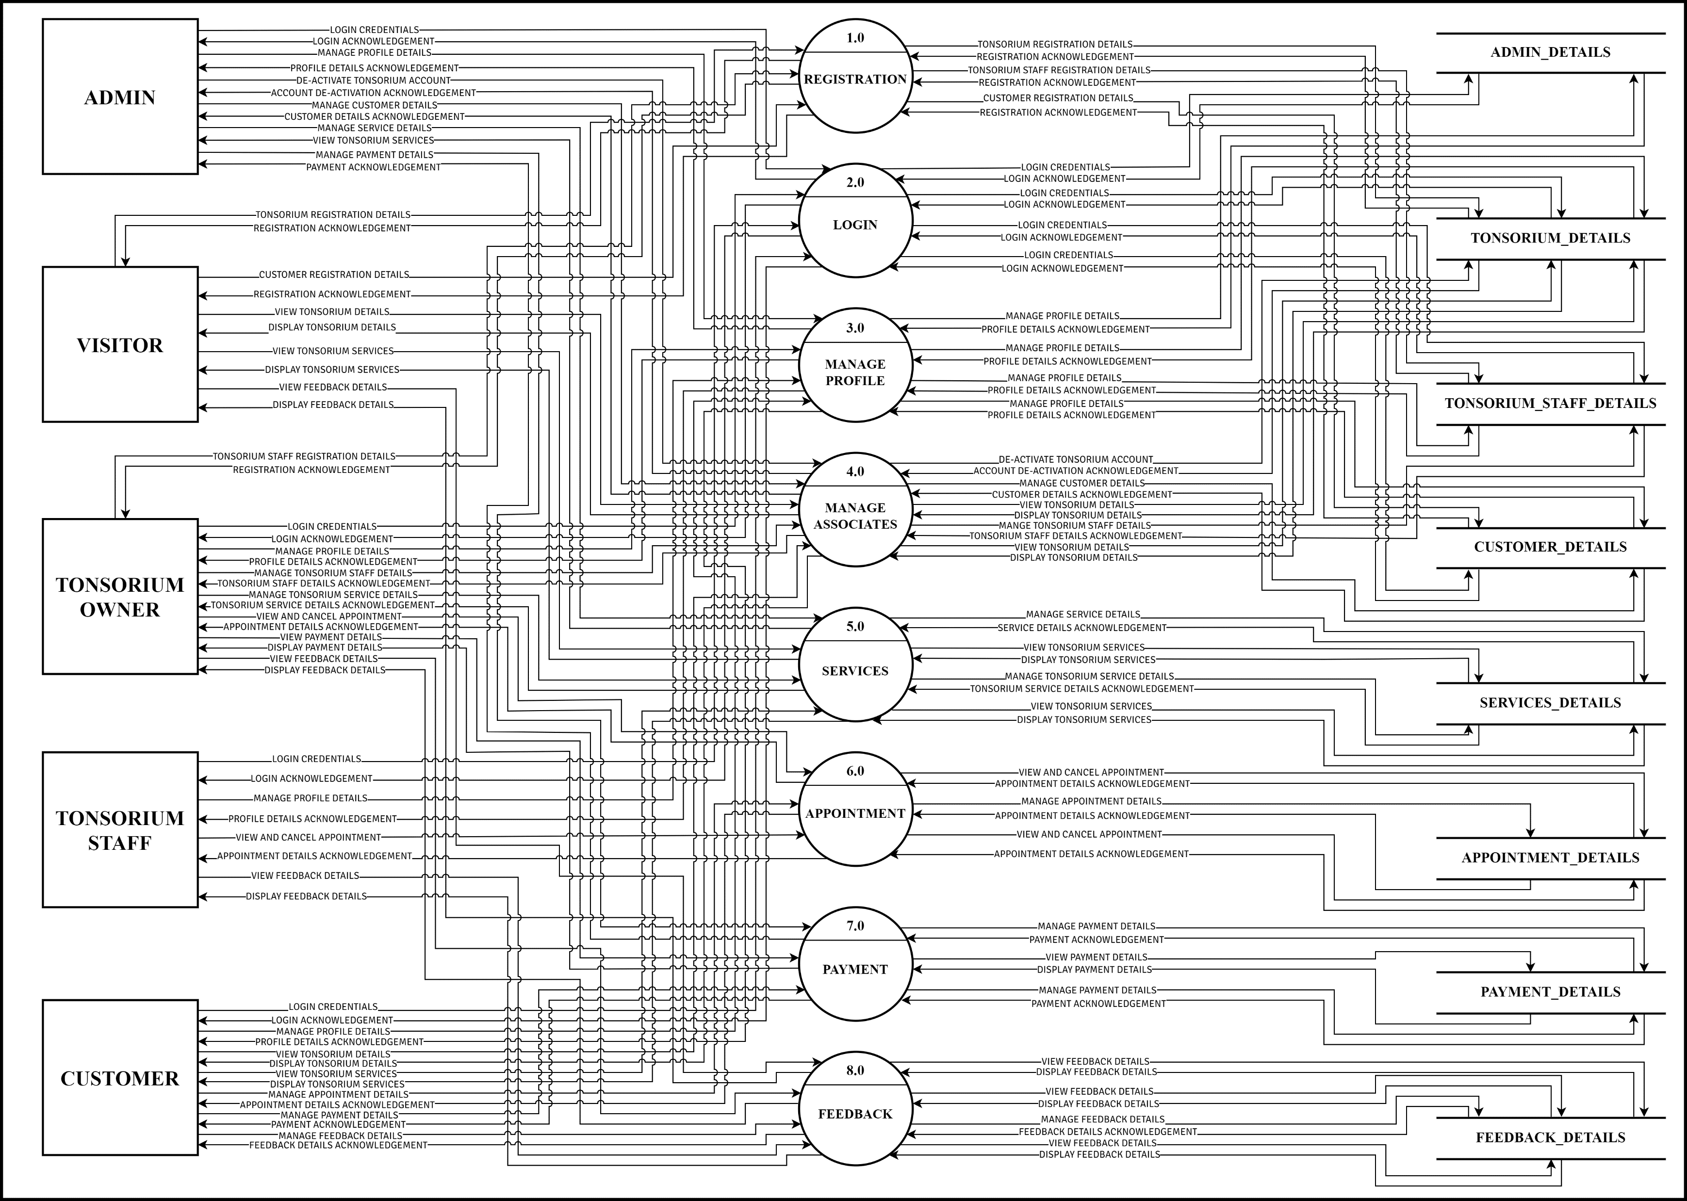

**DFD LEVEL 2**

**LOGIN 2.0**

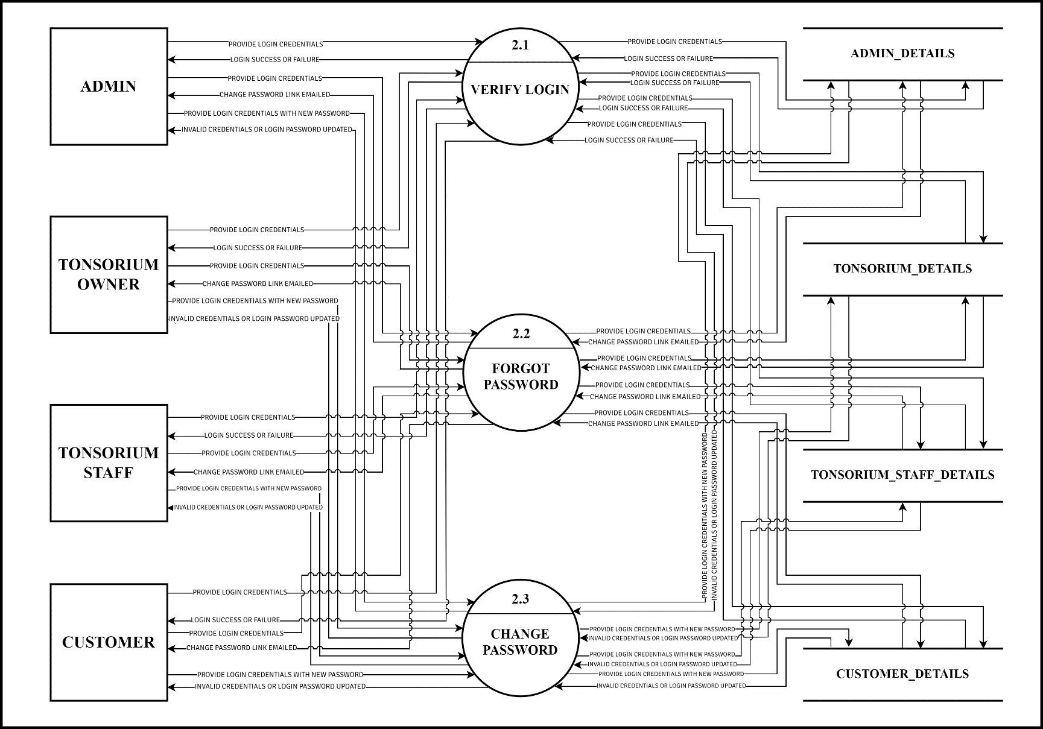

**DFD LEVEL 2**

**MANAGE PROFILE 3.0**

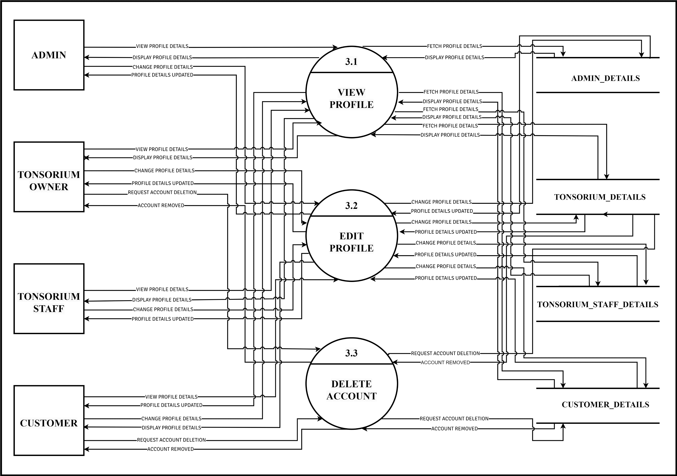

**DFD LEVEL 2**

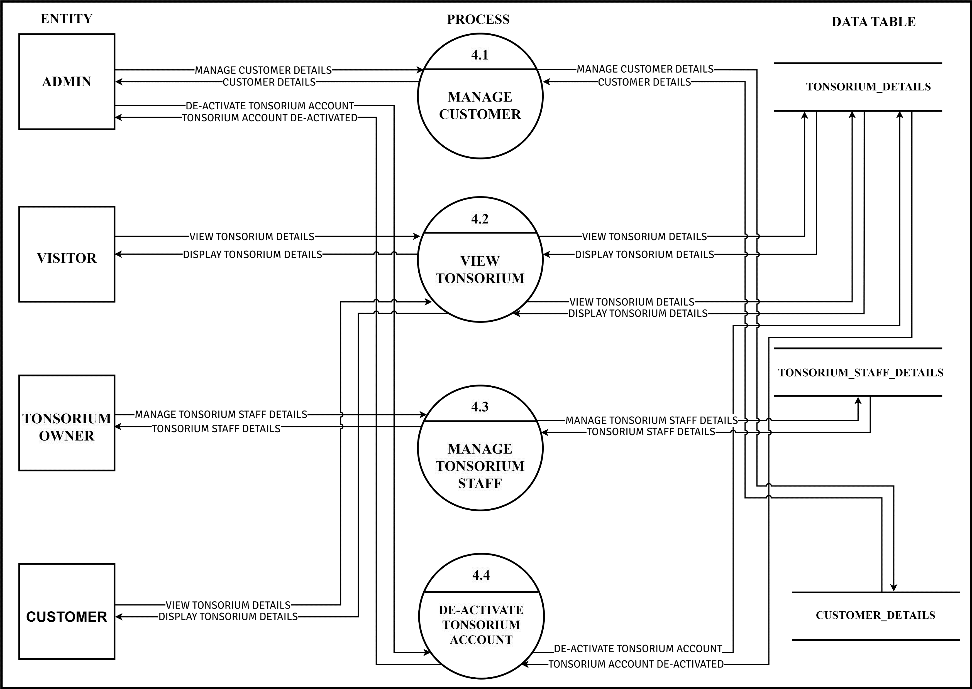**MANAGE ASSOCIATES 4.0**

**DFD LEVEL 2**

**SERVICES 5.0**

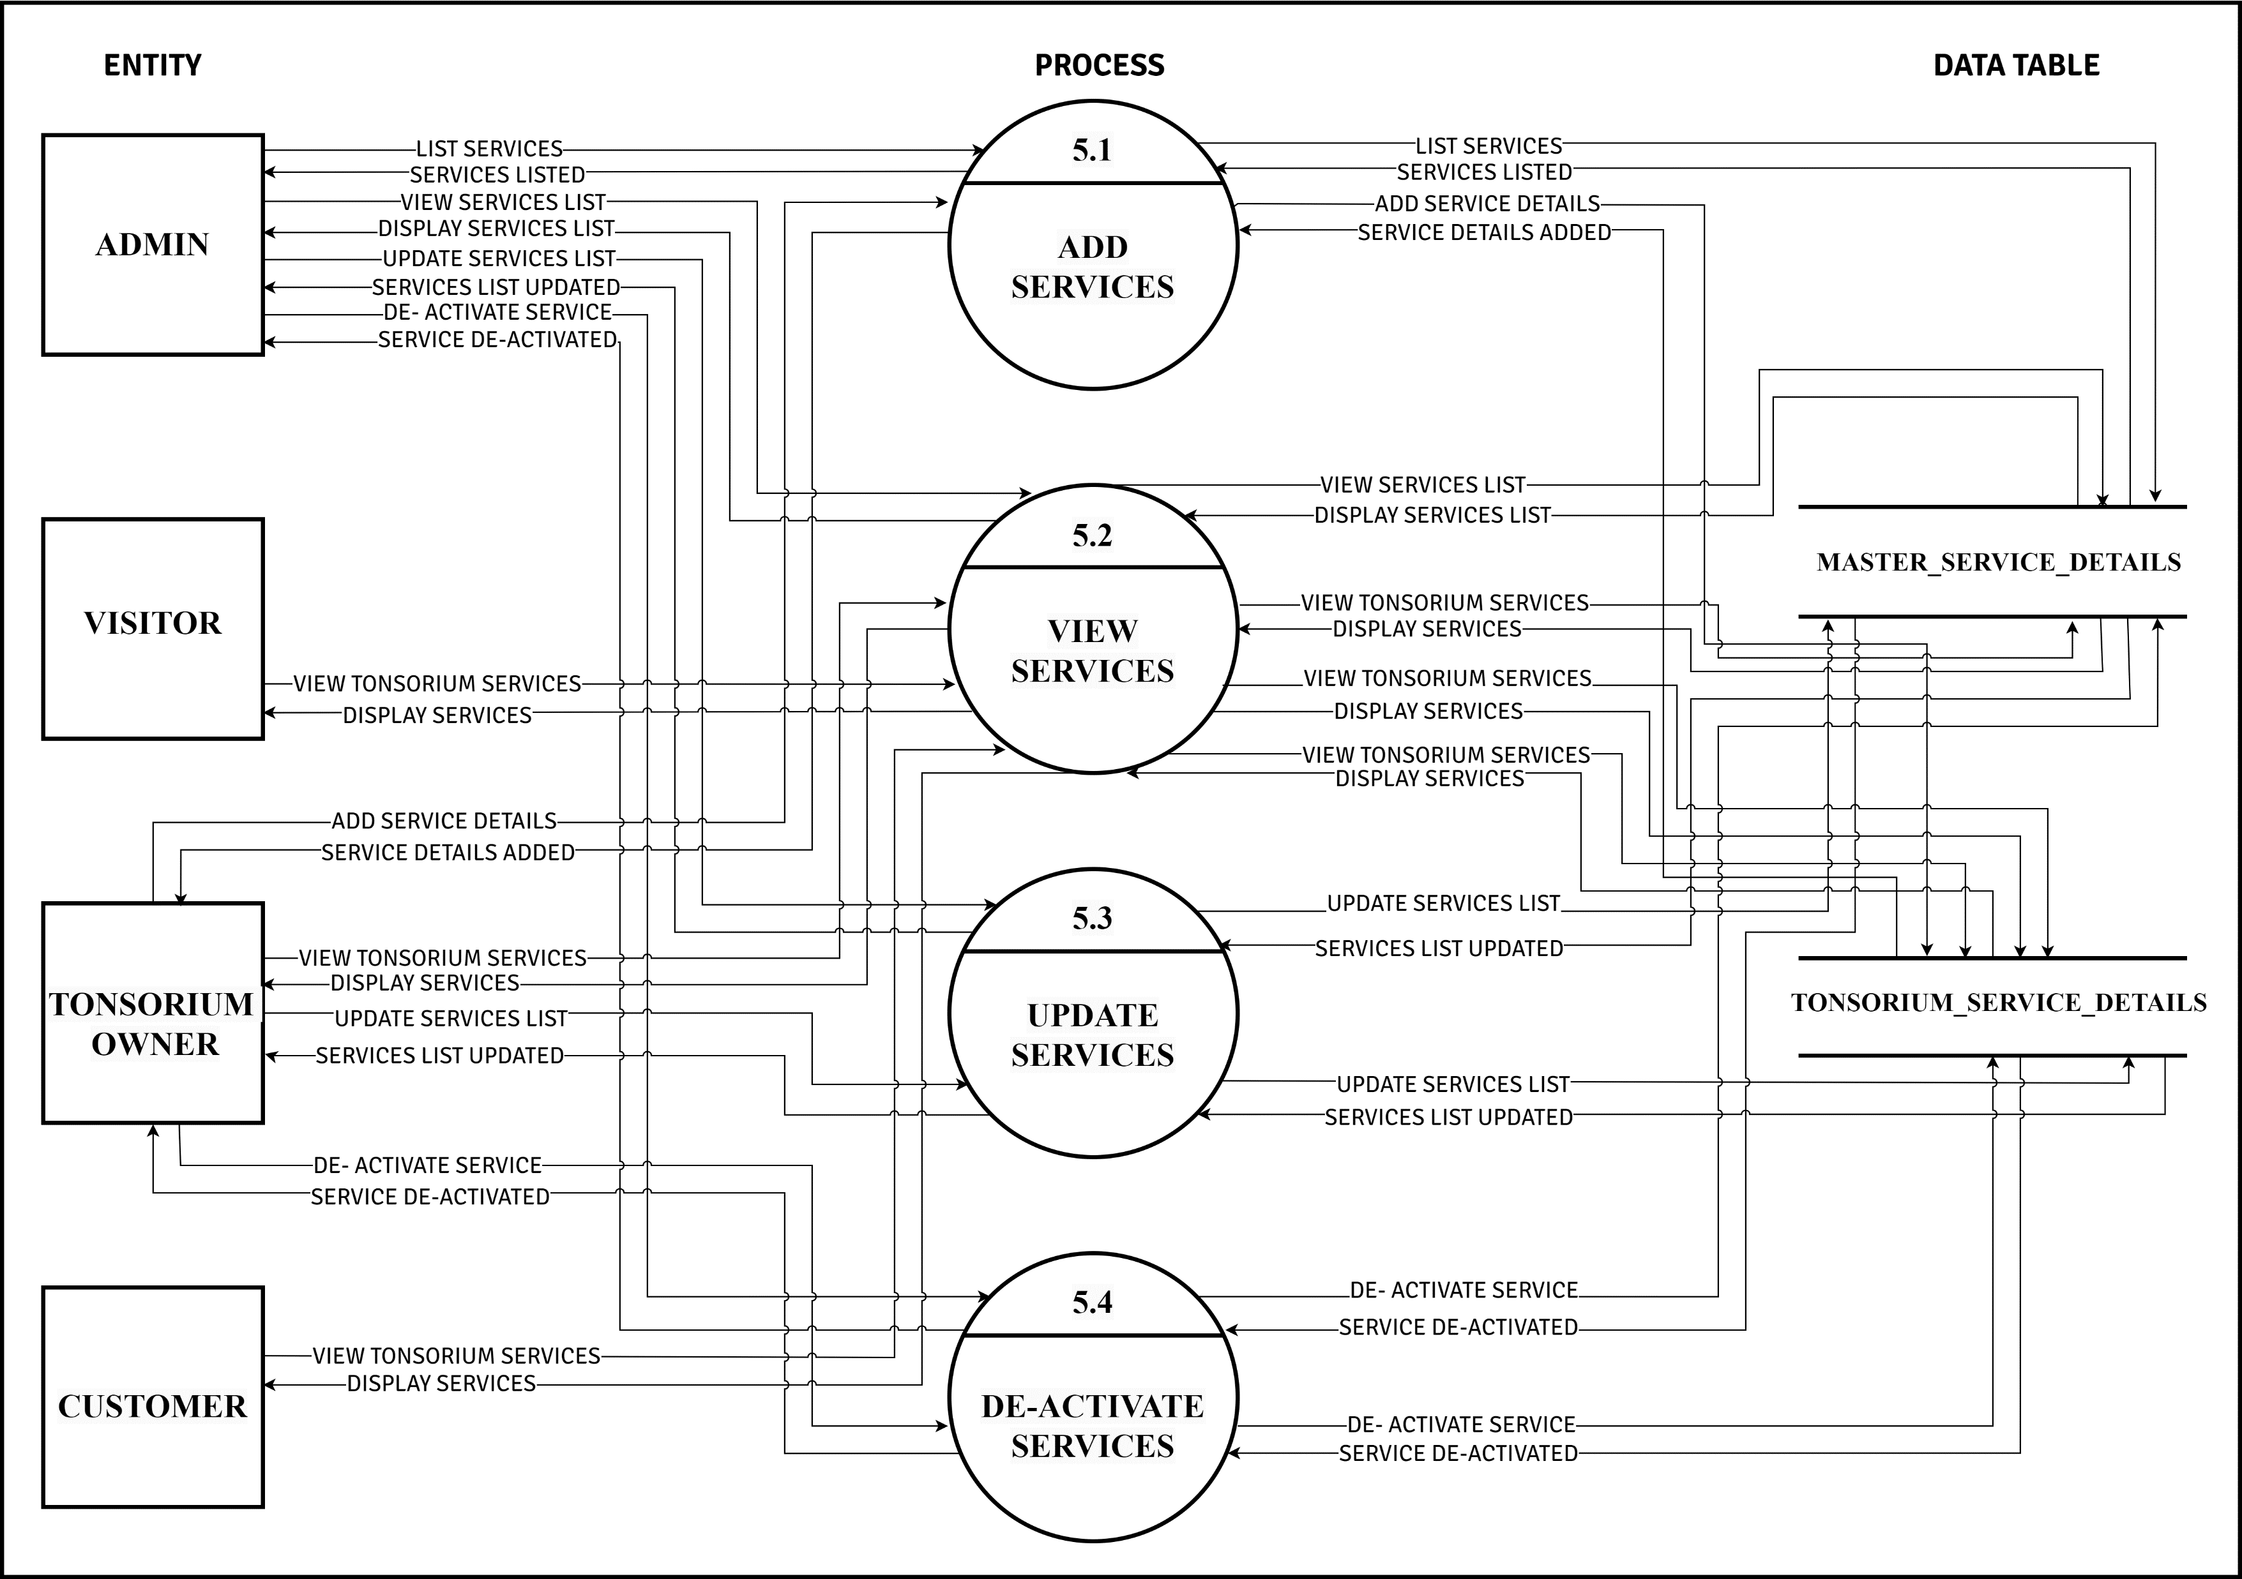

**DFD LEVEL 2**

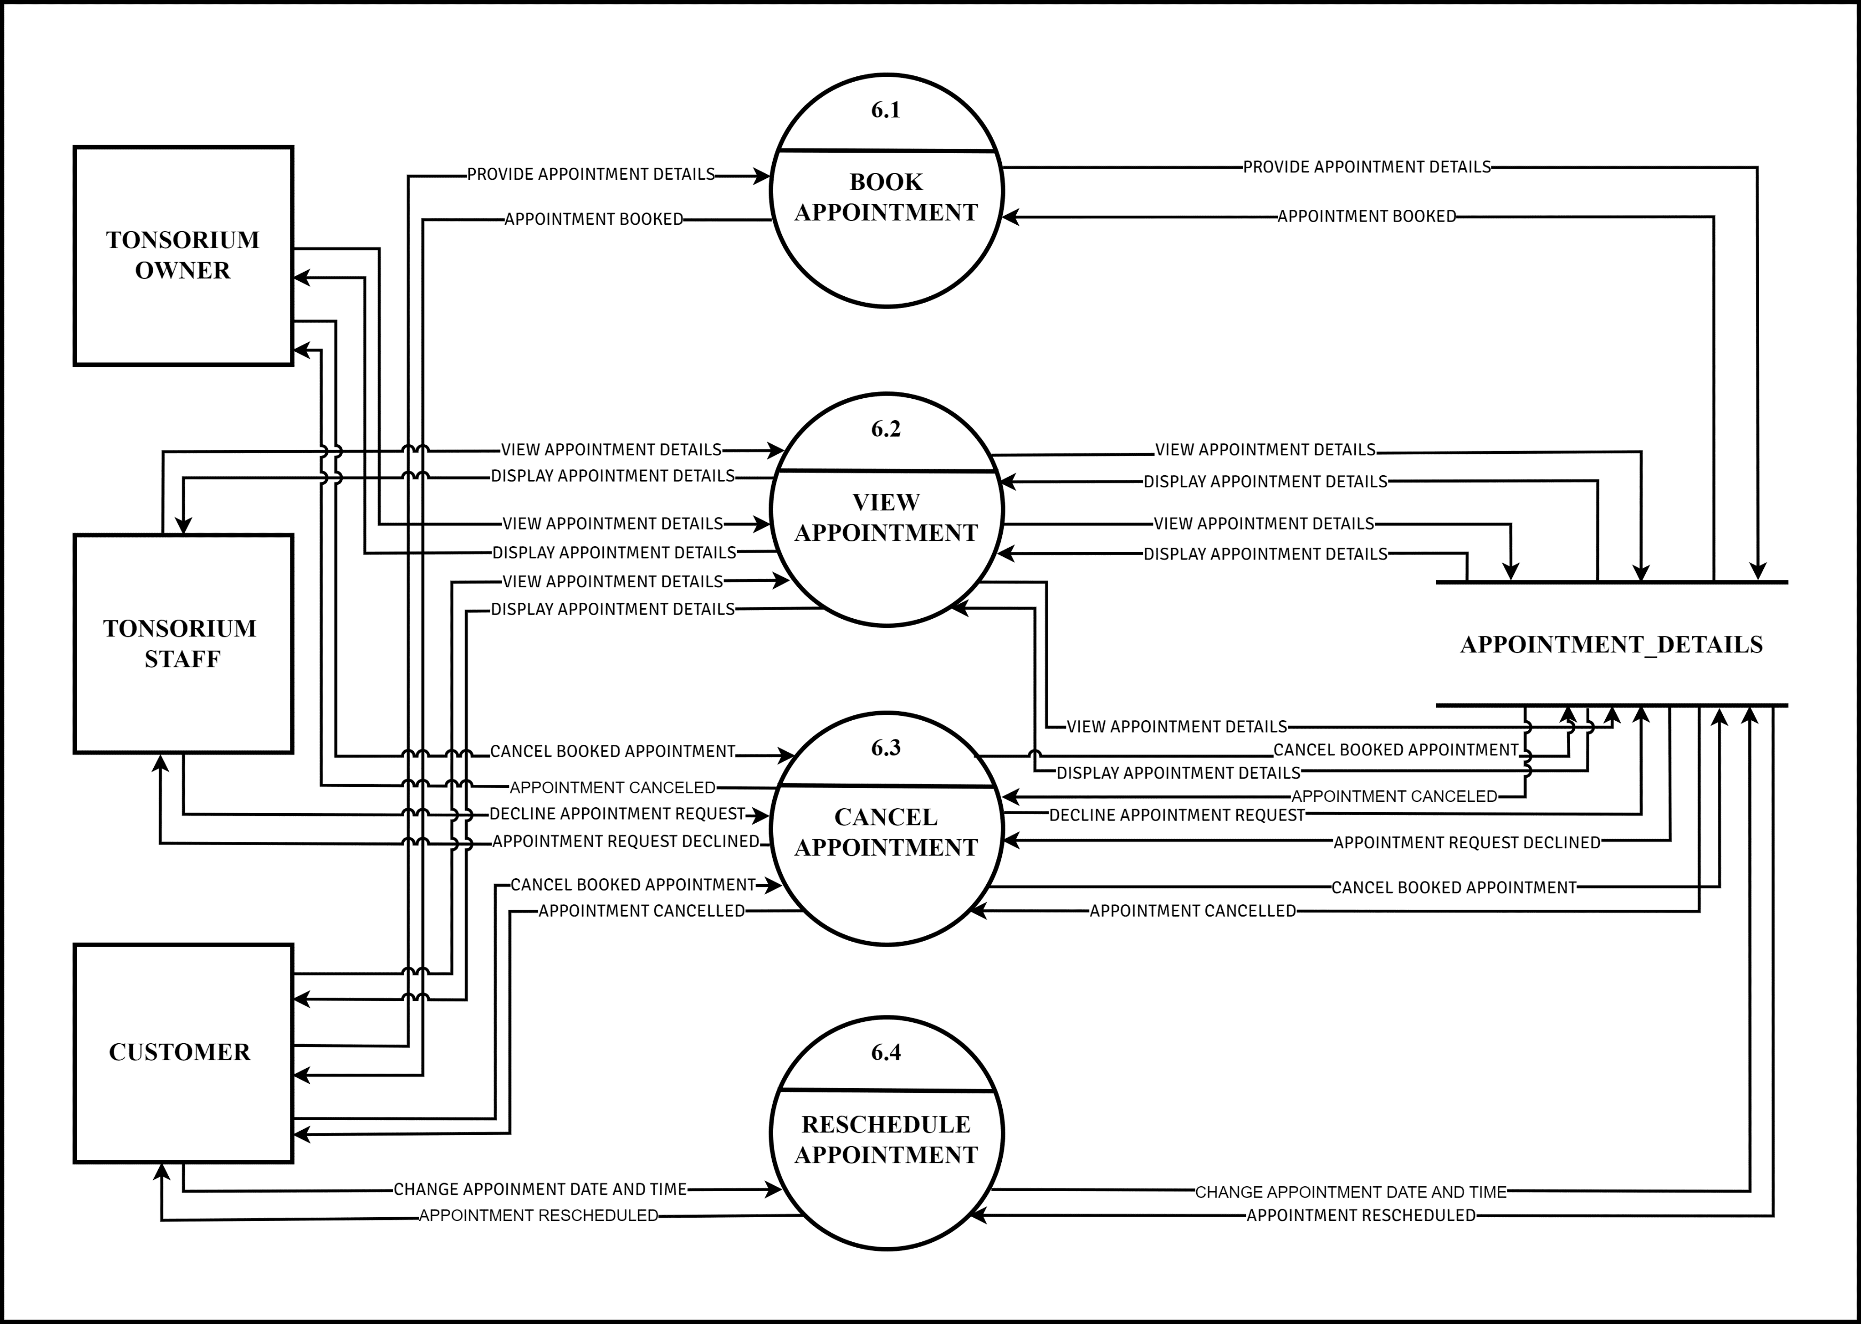**APPOINTMENT 6.0**

**DFD LEVEL 2**

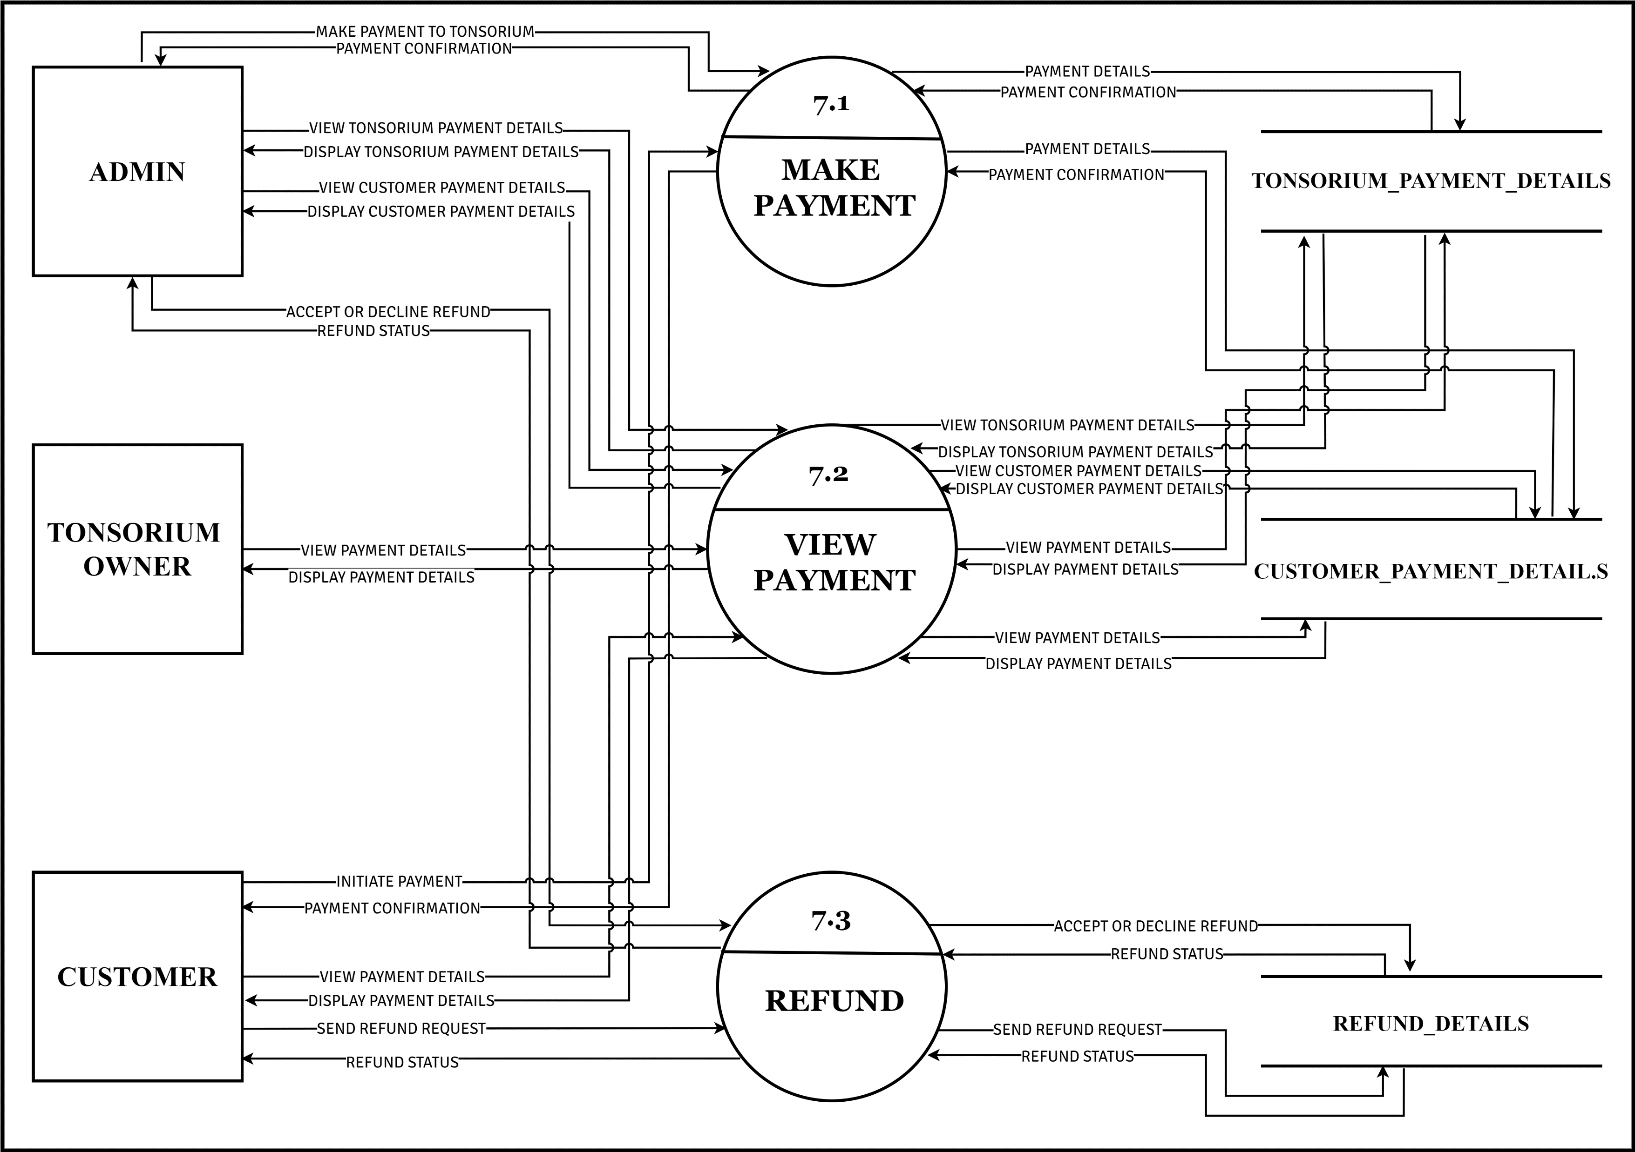**PAYMENT 7.0**

**DFD LEVEL 2**

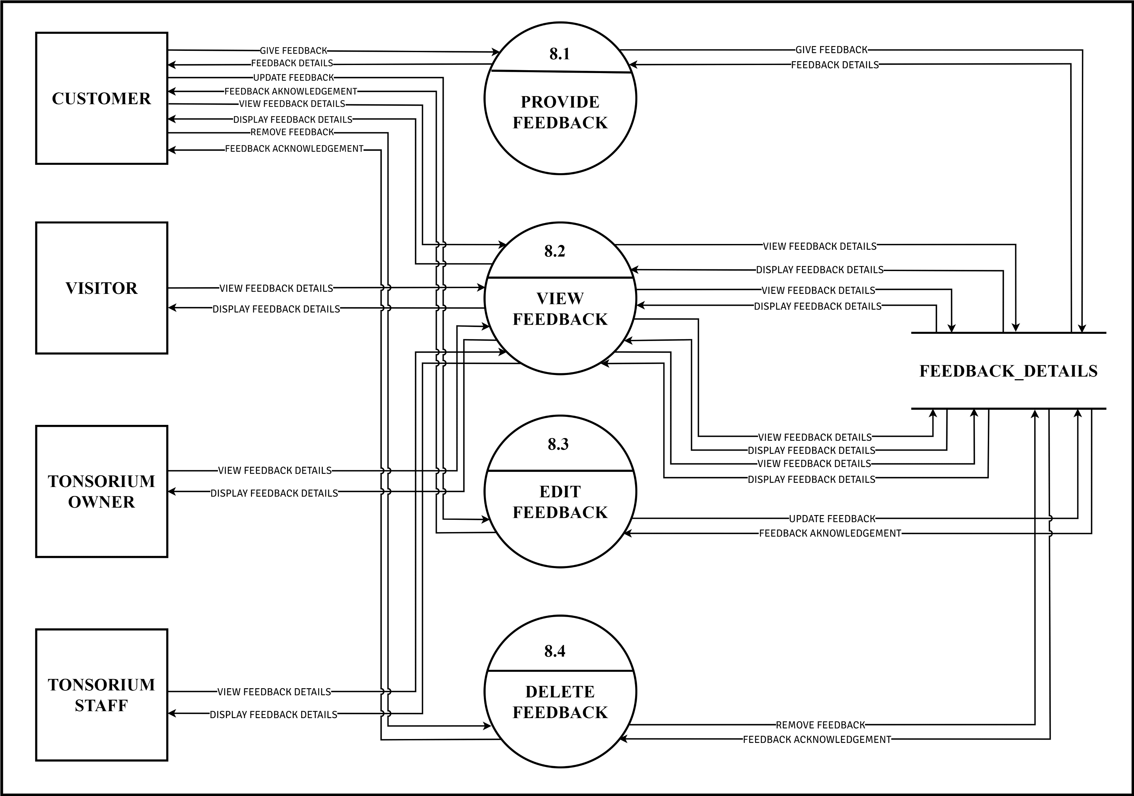**FEEDBACK 8.0**

**MANAGE ASSOCIATES 4.0**

**DFD LEVEL 3**

**MANAGE CUSTOMERS 4.1**

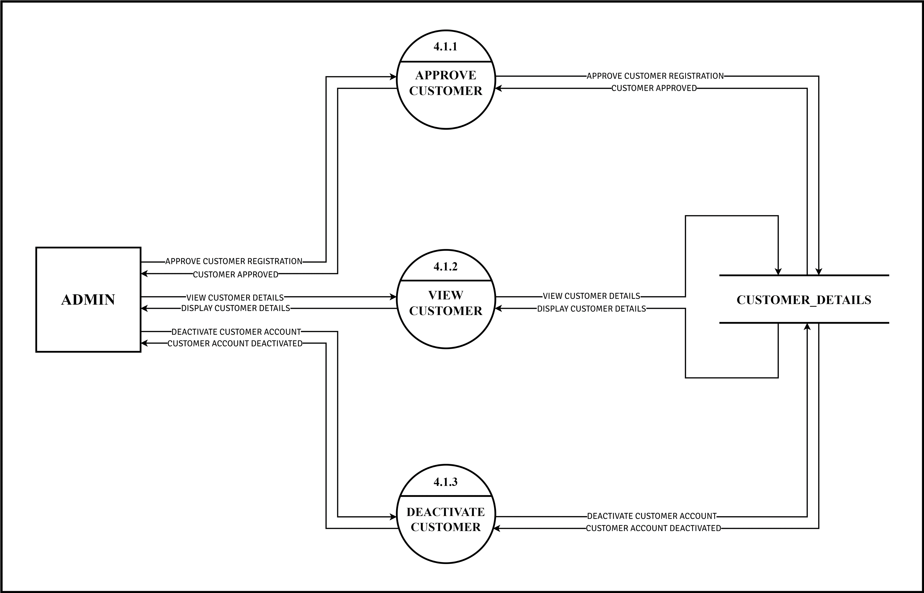

**MANAGE ASSOCIATES 4.0**

**DFD LEVEL 3**

**MANAGE TONSORIUM STAFF 4.3**

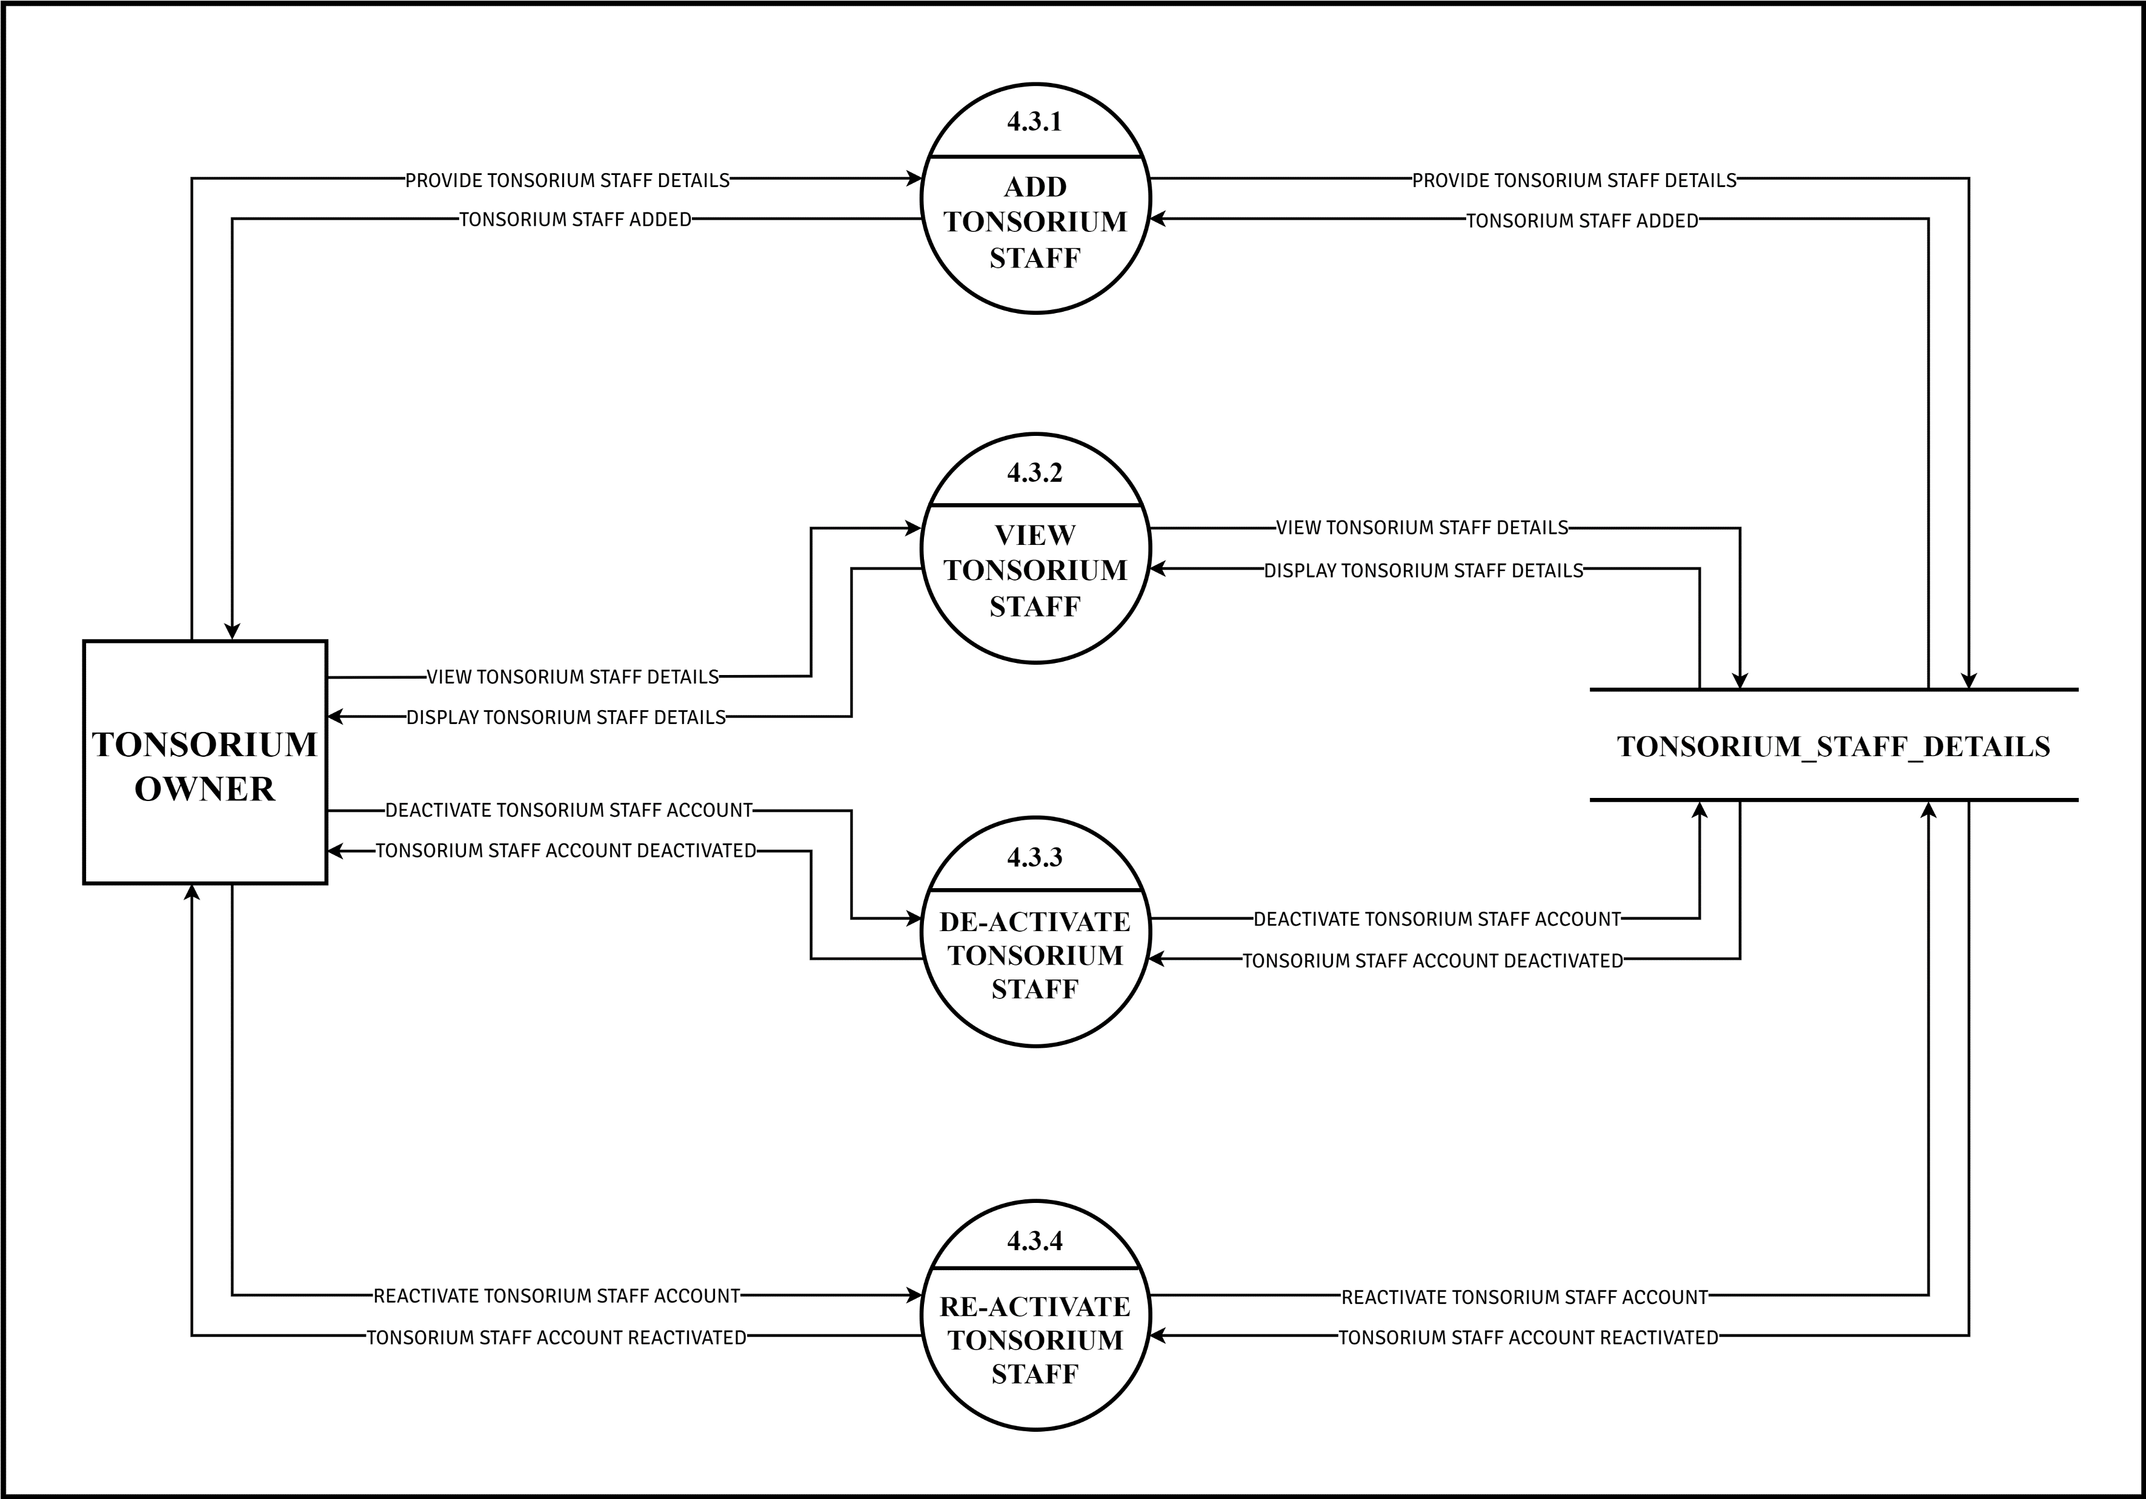

**ENTITY-RELATIONSHIP DIAGRAM**

An Entity Relationship (ER) Diagram is a type of flowchart that illustrates how “entities” such as people, objects or concepts relate to each other within a system. ER Diagrams are most often used to design or debug relational databases in the fields of software engineering, business information systems, education and research. Also known as ERDs or ER Models, they use a defined set of symbols such as rectangles, diamonds, ovals and connecting lines to depict the interconnectedness of entities, relationships and their attributes. They mirror grammatical structure, with entities as nouns and relationships as verbs.

ER diagrams are related to data structure diagrams (DSDs), which focus on the relationships of elements within entities instead of relationships between entities themselves. ER diagrams also are often used in conjunction with data flow diagrams (DFDs), which map out the flow of information for processes or systems.

Entity Relationship (ER) Diagrams can be created using various notations, one of which is the Crow's Foot notation. This notation is widely used to represent the cardinality and participation constraints in the relationships between entities. In Crow's Foot notation, a crow's foot symbol (three lines or "feet") is used to denote the "many" sides of a one-to-many relationship, while a straight line represents the "one" side.

ER diagrams also include strong and weak entities. Strong entities are those that have a primary key attribute, while weak entities do not possess a primary key of their own and rely on a related strong entity for identification. In ER diagrams, strong entities are typically represented by solid line and weak entities by dashed lines.

To summarize, ER diagrams are valuable tools for visualizing and designing the structure of relational databases. They use standardized symbols to illustrate the relationships and attributes of entities within a system, and are often associated with notations like Crow's Foot for cardinality and participation constraints, as well as concepts like strong and weak entities to represent different types of entities in a database schema.

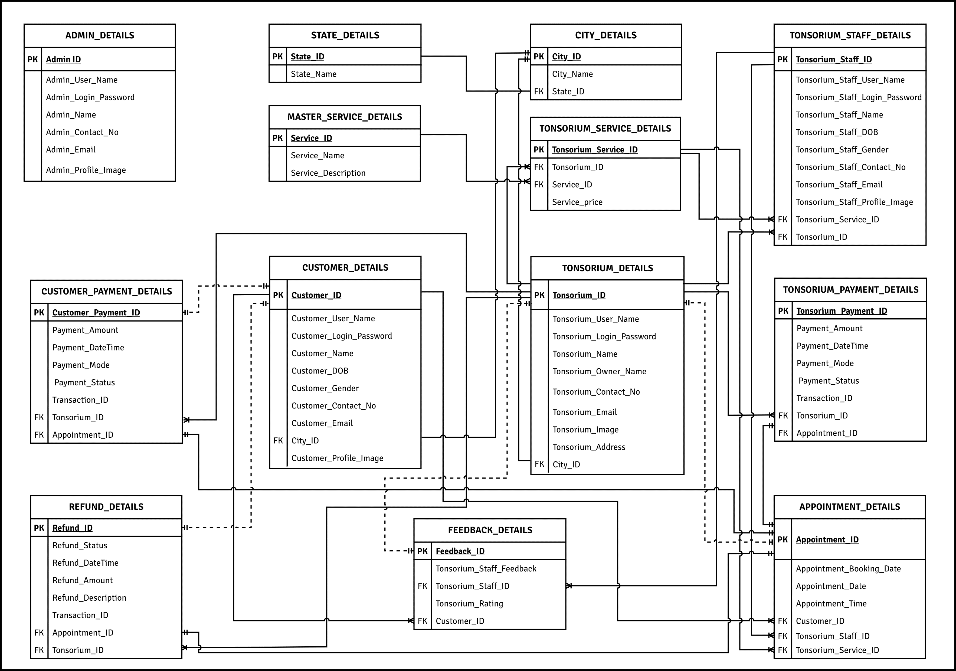

**DATA DICTIONARY**

**LIST OF TABLES:**

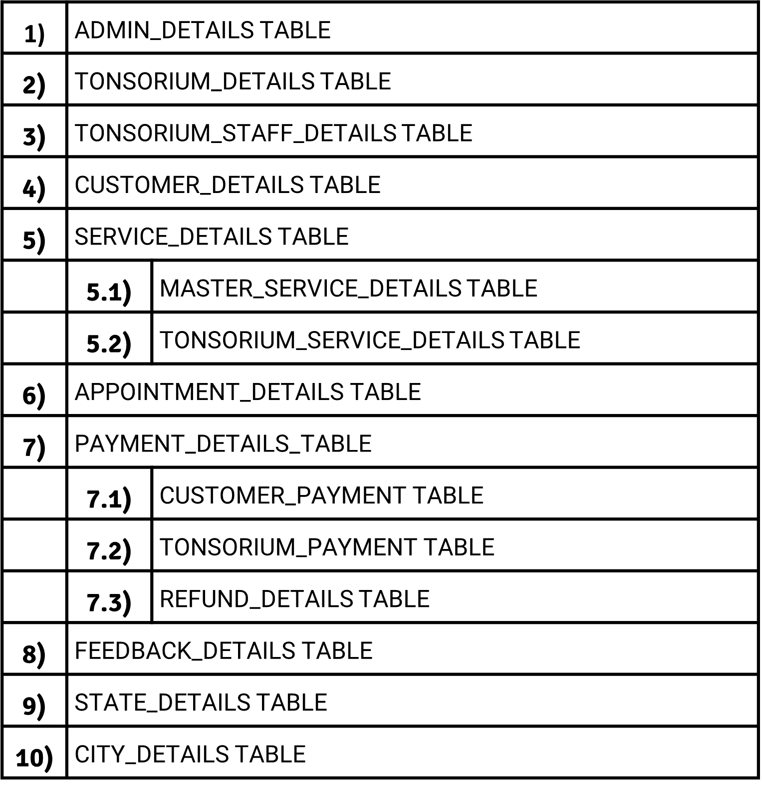

1). TABLE NAME: ADMIN_DETAILS

TABLE DESCRIPTION: This Table stores vital information about all system administrators, including their Admin_ID, username, password, name, contact number, email, and profile image URL.

2). TABLE NAME: TONSORIUM_DETAILS

TABLE DESCRIPTION: The table TONSORIUM_DETAILS stores essential information about all Tonsoriums listed on the website, including their unique ID, username, password, name, owner name, contact number, email, image URL, address, and city ID.



3). TABLE NAME: TONSORIUM_STAFF_DETAILS

TABLE DESCRIPTION: TONSORIUM_STAFF_DETAILS stores essential information about Tonsorium staff, including their unique ID, username, password, name, date of birth, gender, contact number, email, profile image URL, service ID, and Tonsorium ID.



4). TABLE NAME: CUSTOMER_DETAILS

TABLE DESCRIPTION: CUSTOMER_DETAILS stores vital information about all customers using the website, including their unique ID, username, password, name, date of birth, gender, contact number, email, profile image URL, and city ID.



5). TABLE: SERVICE_DETAILS

5.1). TABLE NAME: MASTER_SERVICE_DETAILS

TABLE DESCRIPTION: MASTER_SERVICE_DETAILS table stores all the services listed on the website, including their unique ID, name, description, and category ID.



5.2). TABLE NAME: TONSORIUM_SERVICE_DETAILS

TABLE DESCRIPTION: TONSORIUM_SERVICE_DETAILS table stores all the services offered by a specific Tonsorium with their price.



6). TABLE NAME:APPOINTMENT_DETAILS

TABLE DESCRIPTION: APPOINTMENT_DETAILS table stores the details of all appointments booked by customers, including the appointment ID, booking date, appointment date, time slot, customer ID, tonsorium staff ID, and tonsorium service ID.

7). TABLE: PAYMENT_DETAILS

7.1). TABLE NAME: CUSTOMER_PAYMENT_DETAILS

TABLE DESCRIPTION: CUSTOMER_PAYMENT_DETAILS table stores details of all payments made by customers, including the payment ID, payment amount, payment date and time, payment mode, payment status, transaction ID, tonsorium ID, and appointment ID.



7.2). TABLE NAME:TONSORIUM_PAYMENT_DETAILS

TABLE DESCRIPTION: TONSORIUM_PAYMENT_DETAILS table stores details of all payments made by the Admin to the Tonsorium, including the payment ID, payment amount, payment date and time, payment mode, payment status, transaction ID, tonsorium ID, and appointment ID.



7.3). TABLE NAME: REFUND_DETAILS

TABLE DESCRIPTION: REFUND_DETAILS table stores details of all refunds made to customers, including the refund ID, refund status, refund date and time, refund amount, refund description, transaction ID, tonsorium ID, and appointment ID.



8). TABLE NAME: FEEDBACK_DETAILS

TABLE DESCRIPTION: FEEDBACK_DETAILS table stores all feedback received from customers, including the feedback ID, customer ID, tonsorium ID, tonsorium staff ID, feedback rating, feedback, and feedback date and time.



9). TABLE NAME:STATE_DETAILS

TABLE DESCRIPION: STATE_DETAILS table will store names of all the States where Tonsorium services are available with its unique state ID.



10). TABLE NAME: CITY_DETAILS

TABLE DESCRIPTION: CITY_DETAILS table will store details of all Cites where Tonsorium services are available including State_ID and City_ID.



**BIBLIOGRAPHY**

Book references

* 1. Magnifying Object-Oriented Analysis & Design

Publisher: PHI Learning Publication

Author: Arpita Gopal & Netra Patil

* 1. System Analysis and Design with UML version 2.0 an Object-Oriented Approach

Publisher: Wiley

Author: Alan Dennis, Barbara Haley Wixom, David Tegarden

Website references:

1. [www.geeksforgeeks.com](http://www.geeksforgeeks.com)
2. [www.stackoverflow.com](http://www.stackoverflow.com)
3. [www.tonsorium.co.uk](http://www.tonsorium.co.uk)

**\*\*\***